# NM Id : NM2023TMID08955

# INTRODUCTION

# Overview

* India is witnessing rapid urbanization, with metropolitan areas experiencing significant population growth and economic development.

# Purpose

* The purpose of this analysis is multifaceted. Firstly, it aims to provide insights into the current state of the housing market in metropolitan areas, examining whether there are patterns of growth, stability, or decline.

# Problem Definition & Design Thinking

* 1. Empathy Map
  2. 
  3. Ideation & Brainstorming Map
  4. 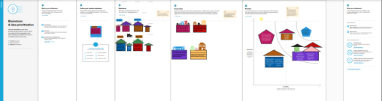

# RESULT

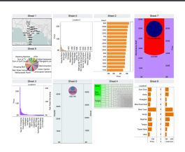 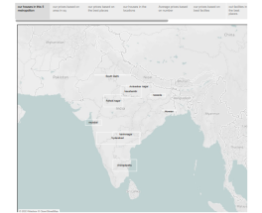

# ADVANTAGES & DISADVANTAGES

# Advantages:

* Analysis helps in understanding the current state of the real estate market in metropolitan areas, including demand and supply dynamics.
* Investors can make informed decisions about where sand when to invest based on trends and forecasts in housing prices.
* Policymakers can use the data to formulate effective housing policies that address affordability issues and ensure sustainable growth.

# Disadvantages:

* The accuracy and reliability of data may be a challenge, especially in emerging markets or areas with limited transparency.
* Real estate markets can be subject to rapid changes, and outdated data may not accurately reflect current market conditions.
* External factors such as political instability, economic downturns, or natural disasters can significantly impact housing prices and are challenging to predict.Top of Form

# APPLICATIONS

# **Real Estate Investment:**

# **Urban Planning**

# **Government Policy:**

# **Homebuyers and Sellers**

# CONCLUSION

* The study revealed significant geographical variations in housing prices across different metropolitan areas. Factors such as proximity to city centers, amenities, and infrastructure played a crucial role in shaping these discrepancies.

# FUTURE SCOPE

* India is undergoing rapid urbanization, and metropolitan areas are expected to experience continued population growth. Analyzing housing prices can help predict trends in urbanization, migration patterns, and housing demands.
* Housing prices are often correlated with economic growth. As India's economy continues to expand, there may be a corresponding impact on housing prices. Future analyses can explore the relationship between GDP growth, employment rates, and housing market dynamics.
* Changes in government policies, such as those related to real estate regulations, affordable housing initiatives, and infrastructure development, can significantly influence housing prices. Monitoring and analyzing these policies can provide insights into future trends.

Top of Form